Task 5: Docker + ECR + ECS Deployment (Using Visual Studio Code)

Project File Structure:
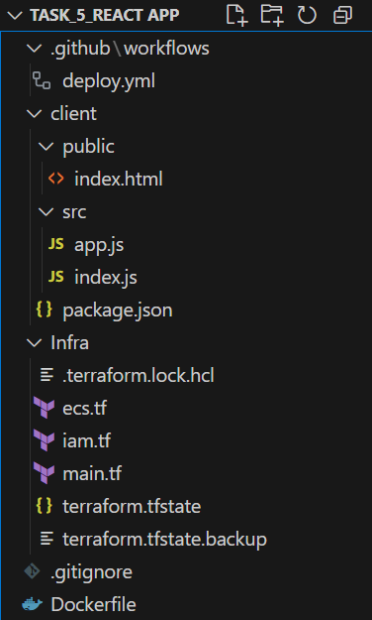

Step 1: Create a Dockerfile to Containerize the React App
- Open your React app project in Visual Studio Code.
- In the root folder, create a file named: Dockerfile
Dockerfile Example:
# Use Node.js base image
FROM node:18 AS build

# Set working directory
WORKDIR /app

# Copy package files and install dependencies
COPY client/package*.json ./
RUN npm install

# Copy the rest of the app and build
COPY client/. .
RUN npm run build

# Use Nginx to serve static files
FROM nginx:alpine
COPY --from=build /app/build /usr/share/nginx/html
EXPOSE 80

CMD ["nginx", "-g", "daemon off;"]

Step 2: Build and Push Docker Image to AWS ECR
- Create ECR repo (if not done already):
- aws ecr create-repository --repository-name react-app --region ap-south-1
- Authenticate Docker to AWS ECR:
- aws ecr get-login-password --region ap-south-1 | docker login --username AWS --password-stdin 704899756157.dkr.ecr.ap-south-1.amazonaws.com
- Build Docker image:
- docker build -t react-app .

- Tag Docker image:
- docker tag react-app:latest 704899756157.dkr.ecr.ap-south 1.amazonaws.com/react-app:latest
- Push to ECR:
- docker push 704899756157.dkr.ecr.ap-south-1.amazonaws.com/react-app:latest

Step 3: Client/public/
- index.html

<!DOCTYPE html>
<html lang="en">
<head>
<meta charset="UTF-8" />
<title>Task-5: Docker ECR ECS Deployment</title>
<style>
body {
font-family: Arial, sans-serif;
background-color: #f0f4f8;
color: #333;
padding: 20px;
}
h1 {
color: #2c3e50;
}
h2 {
color: #16a085;
}
</style>
</head>
<body>
<h1>Deploy React Application</h1>
<br>
<h2>Task-5: Docker ECR ECS Deployment</h2>
<br><br>
<div id="root"></div>
</body>
</html>

Client/src/
- package.json:
{
"name": "my-react-app",
"version": "1.0.0",
"scripts": {
"start": "react-scripts start",
"build": "react-scripts build"
},
"dependencies": {
"react": "^18.2.0",
"react-dom": "^18.2.0",
"react-scripts": "5.0.1"
}
}

Client/src/
- app.js:
import React from "react";

function App() {
return <h1>Hello from React!</h1>;
}

export default App;

Client/src/
- index.js:
import React from "react";
import ReactDOM from "react-dom/client";
import App from "./app";

const root = ReactDOM.createRoot(document.getElementById("root"));
root.render(<App />);

Step 3: Use Terraform to Provision ECS Cluster & Deploy Container
- In your project, create a folder infra and add Terraform files:
- main.tf
provider "aws" {
region = "ap-south-1"
}

resource "aws_ecs_cluster" "react_cluster" {
name = "react-ecs-cluster"
}
- ecs.tf
resource "aws_ecs_task_definition" "react_task" {
family = "react-task"
network_mode = "awsvpc"
requires_compatibilities = ["FARGATE"]
cpu = "256"
memory = "512"
execution_role_arn = aws_iam_role.ecs_task_execution.arn
container_definitions = jsonencode([
{
name = "react-container",
image = "704899756157.dkr.ecr.ap-south-1.amazonaws.com/react-app:latest",
portMappings = [
{
containerPort = 80,
protocol = "tcp"
}
]
}
])
}

resource "aws_ecs_service" "react_service" {
name = "react-service"
cluster = aws_ecs_cluster.react_cluster.id
task_definition = aws_ecs_task_definition.react_task.arn
desired_count = 1
launch_type = "FARGATE"

network_configuration {
subnets = ["subnet-0bcc4063fc386f78d"]
security_groups = ["sg-05de7b74756ec4b38"]
assign_public_ip = true
}
}
- iam.tf (for ECS execution role)
resource "aws_iam_role" "ecs_task_execution" {
name = "ecsTaskExecutionRole"
assume_role_policy = jsonencode({
Version = "2012-10-17",
Statement = [
{
Action = "sts:AssumeRole",
Effect = "Allow",
Principal = {
Service = "ecs-tasks.amazonaws.com"
}
}
]
})
}

resource "aws_iam_role_policy_attachment" "ecs_task_execution_policy" {
role = aws_iam_role.ecs_task_execution.name
policy_arn = "arn:aws:iam::aws:policy/service-role/AmazonECSTaskExecutionRolePolicy"
}
- Initialize and deploy with Terraform:
  - cd infra
  - terraform init
  - terraform apply

Step 4: Automate Deployment via GitHub Actions
- In the root of your project, create: .github/workflows/deploy.yml
- deploy.yml
name: Deploy to ECS

on:
push:
branches:
- main

jobs:
deploy:
name: Build Docker, Push to ECR, Deploy with Terraform
runs-on: ubuntu-latest

steps:
- name: Checkout code
uses: actions/checkout@v3

- name: Set up Docker Buildx
uses: docker/setup-buildx-action@v3

- name: Configure AWS credentials
uses: aws-actions/configure-aws-credentials@v2
with:
aws-access-key-id: ${{ secrets.AWS_ACCESS_KEY_ID }}
aws-secret-access-key: ${{ secrets.AWS_SECRET_ACCESS_KEY }}
aws-region: ap-south-1

- name: Log in to Amazon ECR
uses: aws-actions/amazon-ecr-login@v1

- name: Build, tag, and push image to ECR
run: |
docker build -t react-app .
docker tag react-app:latest 704899756157.dkr.ecr.ap-south-1.amazonaws.com/react-app:latest
docker push 704899756157.dkr.ecr.ap-south-1.amazonaws.com/react-app:latest

- name: Set up Terraform
uses: hashicorp/setup-terraform@v2

- name: Terraform Init
run: terraform init
working-directory: ./Infra

- name: Terraform Apply
run: terraform apply -auto-approve
working-directory: ./Infra

- Add AWS credentials as GitHub repository secrets:
  - AWS_ACCESS_KEY_ID
  - AWS_SECRET_ACCESS_KEY
- .gitignore:
.terraform/

Step 5: Push to main Branch
- When you push code to the main branch:
- git add .
- git commit -m "trigger ECS deploy"
- git push origin main

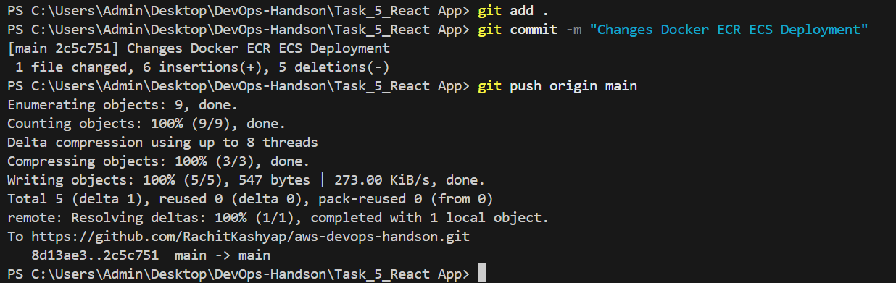
GitHub Actions will:
- Build Docker image.
- Push it to ECR.
- Run Terraform to deploy the latest container on ECS.
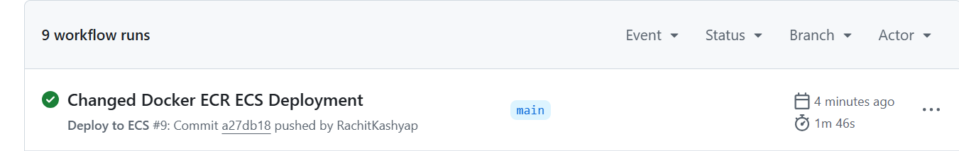
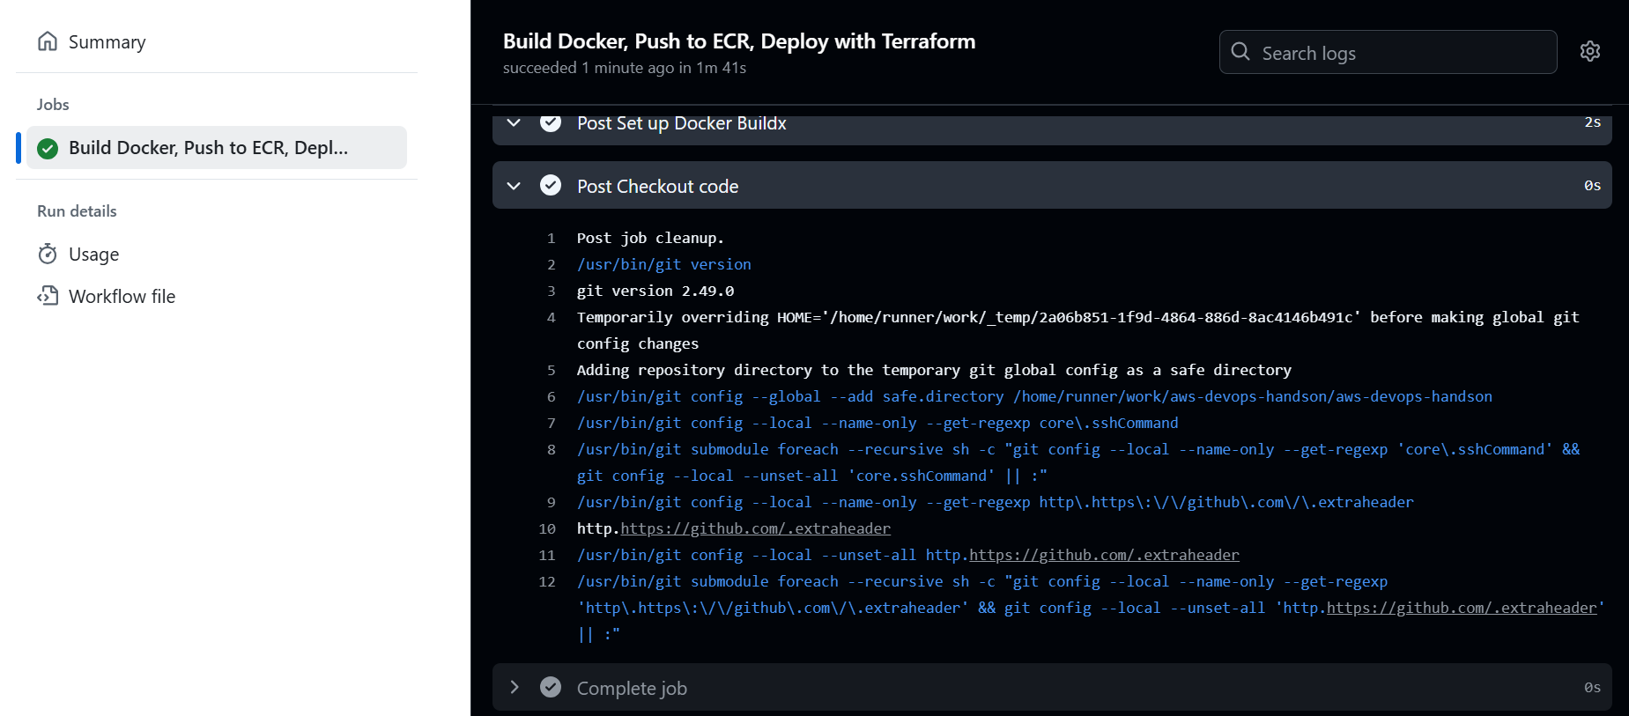

ECR:
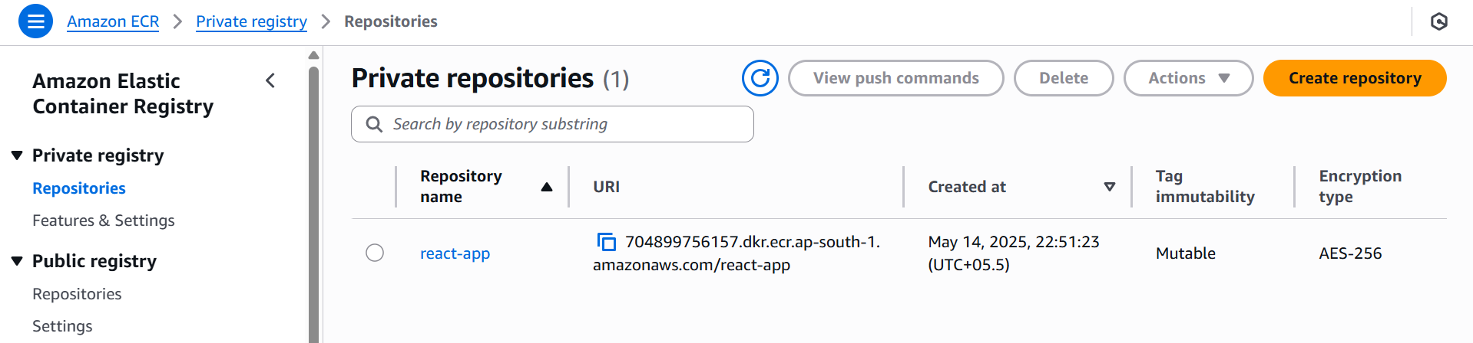
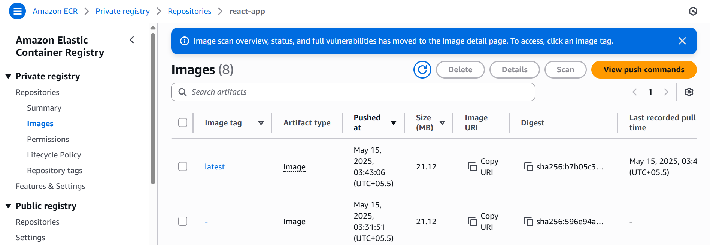

ECS:
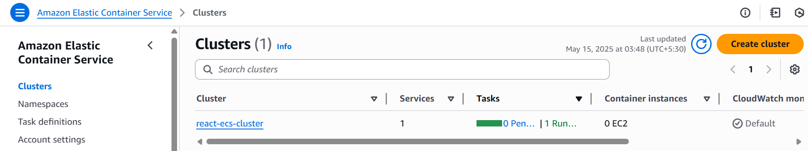

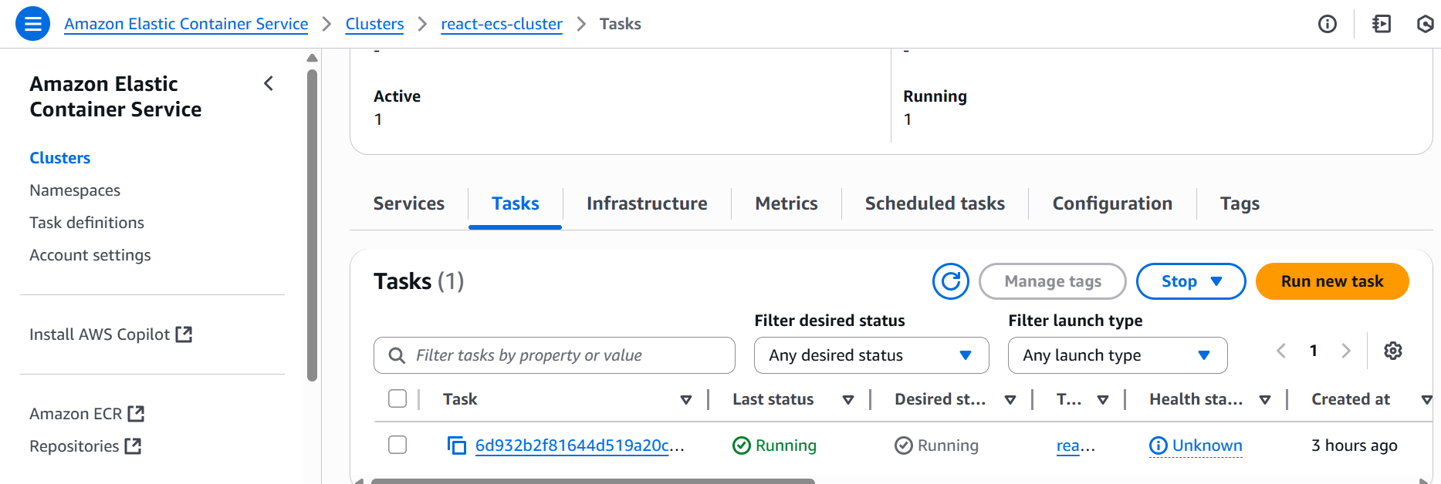

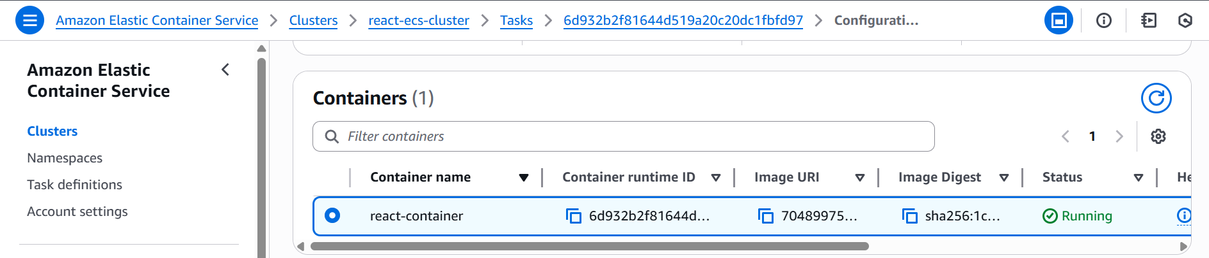
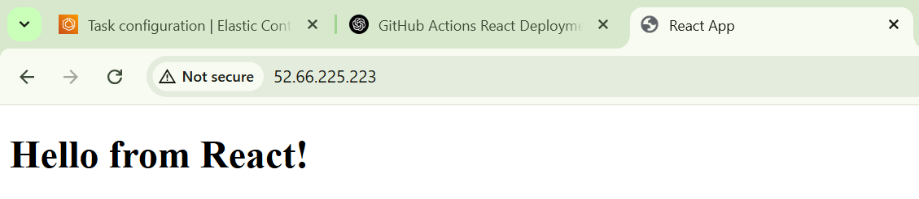

Delete ECR and ECS Service:

- aws ecs delete-service --cluster react-ecs-cluster --service react-service -–force
- aws ecr delete-repository --repository-name react-app –force

Summary:

Daily Standup Summary – Task 5: Docker + ECR + ECS Deployment
"I containerized the React app using a custom Dockerfile, built and pushed the image to AWS ECR. Then, using Terraform, I provisioned an ECS cluster and deployed the containerized app. I also set up a GitHub Actions workflow to automate the CI/CD process — it builds the Docker image, pushes it to ECR, and triggers Terraform to deploy to ECS on every main branch push. Additionally, I validated the deployment through the public load balancer URL and cleaned up ECS and ECR resources post-verification."

